In Memoriam

Dr. Sean Marrett: A Life of Joyful Engagement

Peter Bandettini¹, Bruce Fischl^{2,4}, Richard Hoge³, Albert Gjedde⁵ and Alan Evans³

¹ National Institute of Mental Health, Bethesda, MD
² Martinos Center, Massachusetts General Hospital, Boston, MA
³ McGill University, Montreal, Quebec, CA
⁴ Department of Radiology, Harvard Medical School, Boston, MA.
⁵ University of Copenhagen, Copenhagen, DK

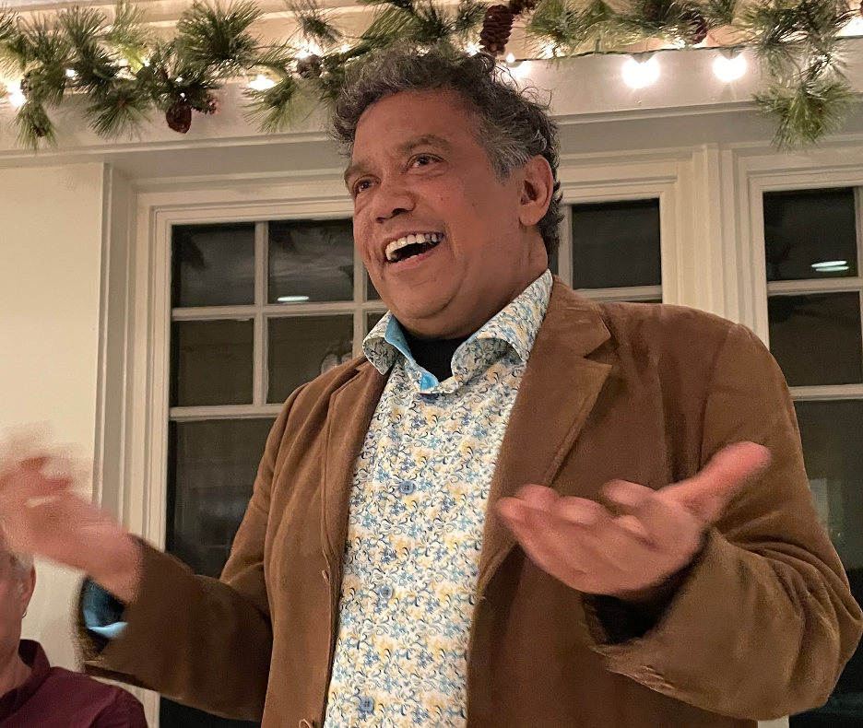

Dr. Sean Marrett, a treasured staff scientist for the NIH intramural program’s Functional MRI Facility (FMRIF) for over 20 years, passed away on December 12, 2023, after a 16-month battle with mesothelioma at the age of 62. The cruel irony is that it was discovered weeks before his planned retirement. Sean radiated “joie de vivre” more strongly than anyone we have ever known, and has touched so many within the NIH IRP and international brain imaging community.

After receiving his Bachelor’s degree in Electrical Engineering from McGill University in 1983, Sean took the position of system manager and programmer under Dr. Alan Evans in the McConnell Brain Imaging Center (BIC) at the Montreal Neurological Institute. It was immediately obvious that Sean was a brilliant mind with a passion for the scientific side of BIC life. He dove into many aspects of the work there, most notably with Drs. Keith Worsley, Evans and Peter Neelin in their legendary ‘Bunker’ office meetings on the spatial statistics of activation studies with PET and fMRI. Sean later received his Ph.D. in Neuroscience from McGill University, supervised by Dr. Albert Gjedde, on oxidative metabolism in the brain. Albert was a close friend of Sean’s, harboring a great respect and affection. According to Albert, Sean in many ways inspired the development of PET imaging in Denmark, beginning with the deposit of an early device from Montreal in Copenhagen, and a second device in Aarhus that Sean came to work with and to use to develop novel imaging methods for the mapping of oxygen metabolism and blood flow.

He carried out his post-doc at the Massachusetts General Hospital (MGH) NMR Center (now the Martinos Center) from 1997 to 2000, training under the PhD scientists Bruce Rosen, Roger Tootell, and Anders Dale during their seminal fMRI-based research on the human visual system. In his time at MGH, Sean contributed to the many projects probing the retinotopic and frequency-tuning characteristics of human early visual cortex. He also made significant contributions to the software that would go on to become the FreeSurfer suite of neuroimaging analysis tools. His burgeoning skills during his postdoctoral research years illustrated Sean’s seminal strengths: he combined a wide-ranging curiosity, a deep and broad knowledge of human neuroimaging and neurophysiology with technical skills that enabled him to enhance the research of the many scientists who were fortunate enough to interact with him.

In 2000, he joined the nascent, jointly funded NINDS/NIMH FMRIF, as a staff scientist. Sean’s influence has permeated the NIH brain imaging community. He forged the positive, open, and helpful culture that now defines the FMRIF. Over the course of 20 years, thousands have been helped by Sean. As the de facto FMRIF manager, the multitude of tasks he performed included balancing the budget, creating the computational and stimulus infrastructure, and troubleshooting innumerable issues as they came up – all while setting the tone and policy of how the FMRIF is run. He successfully navigated the siting and installation of five of our scanners, including our two recent 7T scanners. Lastly, he collaborated with many groups across several NIH institutes – helping them get the best data possible.

His career spanned the beginnings of functional brain mapping. Nearly every brain imaging scientist from back in the day knew and loved Sean. In Montreal, he was a force of nature, whether engaging in intense scientific debates or carousing with other BICers at the Thompson House student bar. At MGH his contributions helped surface-based analysis become ubiquitous in the study of human cortical function. He was also part of OHBM history, as one of the driving forces behind the OHBM Hackathons and embodied the field’s energy going forward. At national and international meetings, Sean would greet new and old colleagues with his radiant smile and good cheer - as if they were the primary person that he was looking forward to meeting - always knowing what they were working on, and deeply curious to get any updates – personal or professional. His knowledge of the literature was encyclopedic and up to date. This deep grasp of salient information went beyond literature, as he developed a reputation as having a preternatural awareness of what was going on throughout the NMR Center, Clinical Center, IRP, NIH, and brain mapping community worldwide. Of all the people I know, he was among the most intensely curious about literally everything.

In the past decade, his focus of choice was scanner hardware and pulse sequences, and all the possible combinations of resolution, sensitivity, and contrast the latest in each could produce. This was an area initially well outside of his training but in time, he mastered it. When the scanner was open, chances were that he would be there testing a sequence. His favorite meetings, aside from OHBM, were the annual ISMRM (International Society for Magnetic Resonance in Medicine) meeting and the RSNA (Radiological Society for North America) meeting where he would talk shop with as many people as he could. In particular, he loved to make his annual day trip to RSNA to take in the latest in technology, and to deeply engage with the MRI-related vendors. He knew them all on a first name basis, and he was so engaging and obviously caring that almost everyone considered him a good friend.

Sean’s defining traits were his unassuming openness and genuine interest in others as well as a deep empathy for them. Regarding his work and the people he worked with, he really cared. He had boundless energy to personally engage with everyone he met. He would also remind us that we were surrounded by amazing technology and brilliant people. What more could one want? Throughout his personal and professional life, his constant and radiant smile was that of a kid in a candy store. He was a deeply devoted husband and a very proud father to his two sons. He was also a proud Canadian – or more precisely – a proud “Québécois.” He was equally ready to delve into an intense science discussion or to share a laugh or a good story. He was the first to march unhesitatingly into the ocean that he loved, so he could play in the waves, no matter how cold. During his life, and in particular, during his last year, he traveled widely. Each new location was a source of wonder, joy and excitement. It was clear that he embraced this world with every ounce of his being.

He cherished social gatherings and celebrations, and no matter how trivial or inconsequential they may have been, he always mentioned afterwards, “That was so fun! Just wonderful!” Perhaps the most appropriate summary of his life would be his dancing. Anyone who knew Sean also knew, as truth itself, that whenever there was a dance floor, he was ALWAYS out there, drenched in sweat, radiating joy, fully in the moment, dancing as if that was all that ever mattered. He was right.

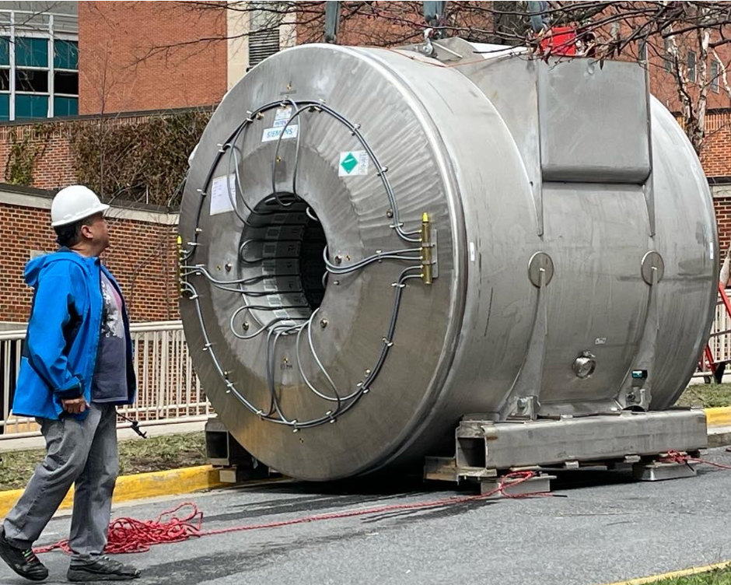

Sean attending to the delivery of the National Institute of Mental Health Functional MRI Facility’s Siemens Terra 7T, March 30, 2022.

