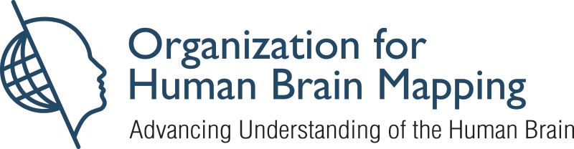

Organization for Human Brain Mapping (OHBM)
Verification of Attendance
This certificate serves as verification that
attended the OHBM 2022 Annual Meeting

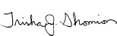

Trish Shomion, OHBM Executive Director
Organization for Human Brain Mapping
1935 Country Rd B2, Suite 165,
Roseville, MN 55113 USA

